**Program 2 – Minishell**

Saj Patel

Description of the assignment:

The main goal of this assignment was to create a C program that will run as a minishell which will run several Linux programs and processes.

Results:

I was able to get the program to fully function. The minishell was able to change the directory, exit the program, execute programs, perform input and output redirections and also run processes in the background. Lab1.c, foo.txt and test.c were used to test input redirection and background processes.

Execution of the code:

Figure : Execution of changing directory and running a programing using input redirection

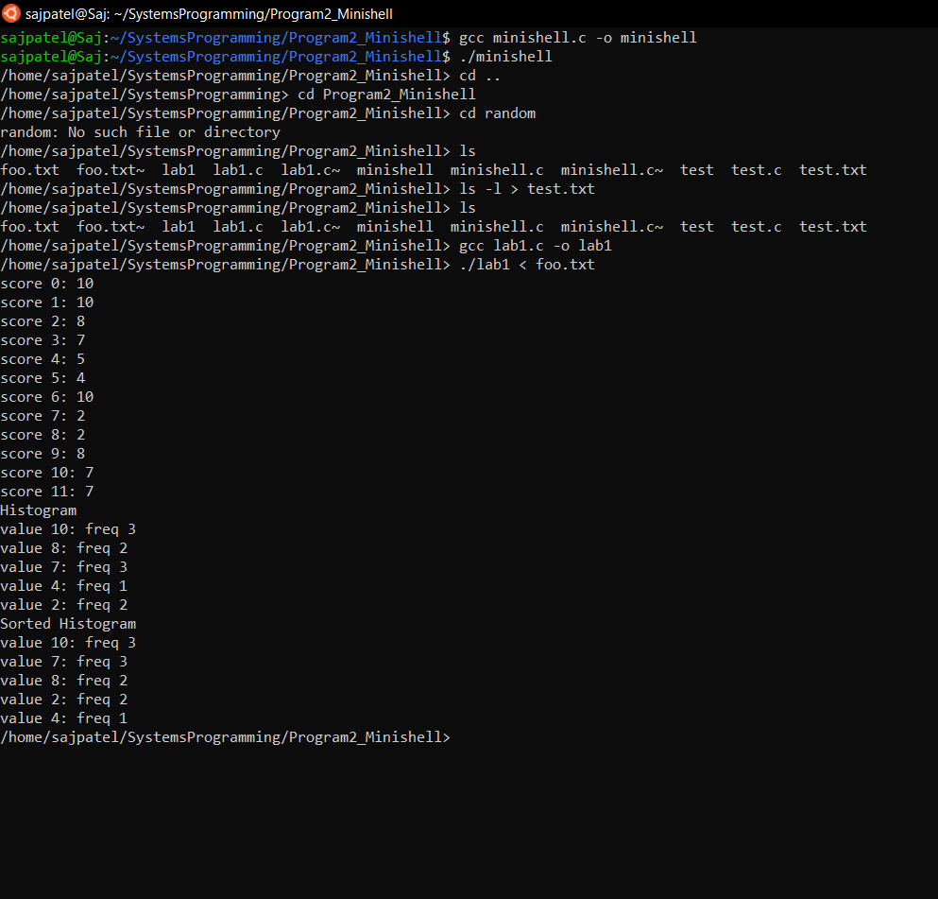

Figure : Output of the ls -l command redirected out to test.txt

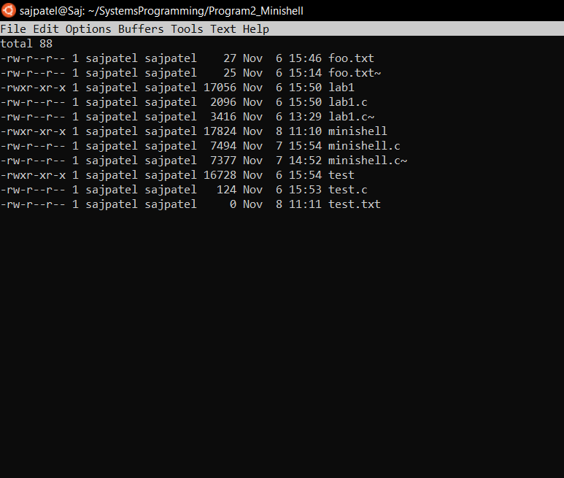

Figure : Output showing background processes can run and other commands including the exit command which closes the program

